**ASSIGNMENT-4**

Ultrasonic sensor simulation in Wokwi

**Question :**

Write a code and connections in wokwi for the ultrasonic sensor. Whenever the distance is less than

100cms send an “Alert” to IBM cloud and display in the device recent events.

**Code:**

#include <WiFi.h>

#include <PubSubClient.h>

void callback(char* subscribetopic, byte* payload, unsigned int

payloadLength);

//-------credentials of IBM Accounts------

#define ORG "vwcvi9"//IBM ORGANITION ID

#define DEVICE_TYPE "ESP32"//Device type mentioned in ibm watson IOT Platform

#define DEVICE_ID "CAC55122-B0DB-4C2B-8DF5-9385E20A41AD"//Device ID mentioned in ibm watson IOT Platform

#define TOKEN "hDorltw6NBxba0godG" //Token

String data3;

char server[] = ORG ".[messaging.internetofthings.ibmcloud.com](http://messaging.internetofthings.ibmcloud.com/)";

char publishTopic[] = "iot-2/evt/Data/fmt/json";

char subscribetopic[] = "iot-2/cmd/test/fmt/String";

char authMethod[] = "use-token-auth";

char token[] = TOKEN;

char clientId[] = "d:" ORG ":" DEVICE_TYPE ":" DEVICE_ID;

WiFiClient wifiClient;

PubSubClient client(server, 1883, callback ,wifiClient);

const int trigPin = 5;

const int echoPin = 18;

#define SOUND_SPEED 0.034

long duration;

float distance;

void setup() {

**Serial**.begin(115200);

pinMode(trigPin, OUTPUT);

pinMode(echoPin, INPUT);

wificonnect();

mqttconnect();

}

void loop()

{

digitalWrite(trigPin, LOW);

delayMicroseconds(2);

digitalWrite(trigPin, HIGH);

delayMicroseconds(10);

digitalWrite(trigPin, LOW);

duration = pulseIn(echoPin, HIGH);

distance = duration * SOUND_SPEED/2;

**Serial**.print("Distance (cm): ");

**Serial**.println(distance);

if(distance>100)

{

**Serial**.println("ALERT!!");

delay(100);

PublishData(distance);

delay(100);

if (!client.loop()) {

mqttconnect();

}

}

delay(100);

}

void PublishData(float dist) {

mqttconnect();

String payload = "{\"Distance\":";

payload += dist;

payload += ",\"ALERT!!\":""\"Distance less than 100cms\"";

payload += "}";

**Serial**.print("Sending payload: ");

**Serial**.println(payload);

if (client.publish(publishTopic, (char*) payload.c_str())) {

**Serial**.println("Publish ok");

} else {

**Serial**.println("Publish failed");

}

}

void mqttconnect() {

if (!client.connected()) {

**Serial**.print("Reconnecting client to ");

**Serial**.println(server);

while (!!!client.connect(clientId, authMethod, token)) {

**Serial**.print(".");

delay(100);

}

initManagedDevice();

**Serial**.println();

}

}

void wificonnect()

{

**Serial**.println();

**Serial**.print("Connecting to ");

WiFi.begin("Wokwi-GUEST", "", 6);

while (WiFi.status() != WL_CONNECTED) {

delay(100);

**Serial**.print(".");

}

**Serial**.println("");

**Serial**.println("WiFi connected");

**Serial**.println("IP address: ");

**Serial**.println(WiFi.localIP());

}

void initManagedDevice() {

if (client.subscribe(subscribetopic)) {

**Serial**.println((subscribetopic));

**Serial**.println("subscribe to cmd OK");

} else {

**Serial**.println("subscribe to cmd FAILED");

}

}

void callback(char* subscribetopic, byte* payload, unsigned int payloadLength)

{

**Serial**.print("callback invoked for topic: ");

**Serial**.println(subscribetopic);

for (int i = 0; i < payloadLength; i++) {

//Serial.print((char)payload[i]);

data3 += (char)payload[i];

}

**Serial**.println("data: "+ data3);

data3="";

}

**Diagram.json:**

{

  "version": 1,

  "author": "sweetysharon",

  "editor": "wokwi",

  "parts": [

    { "type": "wokwi-esp32-devkit-v1", "id": "esp", "top": -4.67, "left": -112.87, "attrs": {} },

    { "type": "wokwi-hc-sr04", "id": "ultrasonic1", "top": 15.96, "left": 89.17, "attrs": {} }

  ],

  "connections": [

    [ "esp:TX0", "$serialMonitor:RX", "", [] ],

    [ "esp:RX0", "$serialMonitor:TX", "", [] ],

    [

      "esp:VIN",

      "ultrasonic1:VCC",

      "red",

      [ "h-37.16", "v-178.79", "h200", "v173.33", "h100.67" ]

    ],

    [ "esp:GND.1", "ultrasonic1:GND", "black", [ "h39.87", "v44.04", "h170" ] ],

    [ "esp:D5", "ultrasonic1:TRIG", "green", [ "h54.54", "v85.07", "h130.67" ] ],

    [ "esp:D18", "ultrasonic1:ECHO", "green", [ "h77.87", "v80.01", "h110" ] ]

  ]

}

**Wokwi simulation link:**

[**https://wokwi.com/projects/346508314441417298**](https://wokwi.com/projects/346508314441417298)

**Circuit Diagram:**

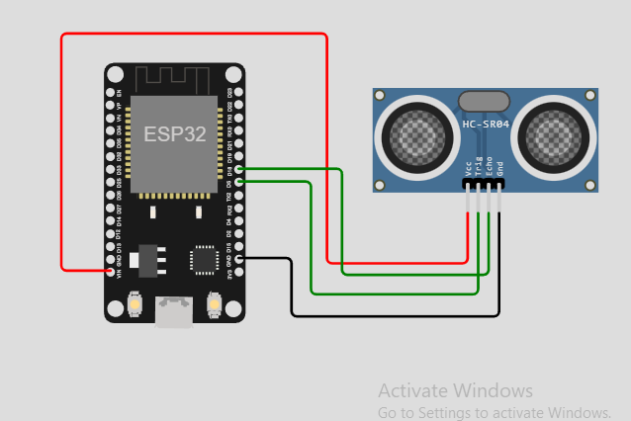

**Output:**

**Wokwi output:**

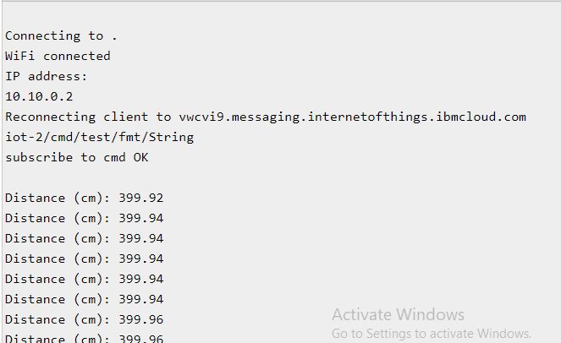

**IBM cloud output:**

